# Introduction

This document details the vision, purpose, requirements, and design of a car-mounted trio of load cells for measuring lift, drag, and moment in place of a wind tunnel substitute. As the development of Crash-Sat continues the needs for an intelligent airframe design and controls system grows. A very important part of these facets is the detailed understanding of dynamics and static aerodynamic behavior. Proper flight coefficients must be determined for modelling a robust controls system and loading profiles must be tested to ensure the structural integrity during the pitching phase; simply to name a couple of examples.

After trade studying aerodynamic analysis options such as CFD, wind tunnels, and numerical solutions; a conclusion was made that these options, though useful in their own way, are not an adequate replacement for the accessibility and direct approach of a real world model under real aerodynamic loading. Additionally the procurement of a wind tunnel for more controlled testing is seen as an unnecessary expensive endeavor. Thus a car-mounted system will be created for testing aerodynamic loading under real aerodynamic effects.

This car mounted system will allow for near 1:1 sized models to be tested in a semi-controlled environment with near immediate availability, barring weather and excessive wind. The design will focus on measurement accuracy and user convenience. Special attention will be given to structural integrity and safety in both the design and testing procedures to ensure the vehicle in use remains road legal and does not pose a threat to any other drivers on the road.

# Requirements

Below in Table 1 is a list of system level (SYS) and pitot tube (PT) requirements to be followed in the design process. Table 1 is a representation of the requirements at the time of writing and more up to date requirements may be present elsewhere.

**Table 1: Requirements list**

|  |  |  |
| --- | --- | --- |
| Req. ID | Description | Priority |
| SYS-1 | The structure must be able to form a non-destructive mount to the roof, or equivalent surface, of a typical American sedan. | Medium |
| SYS-2 | The primary structure and car mounting interface must be able to withstand up to 10 pounds of lift, and 30 pounds of drag, with damage to the vehicle. | High |
| SYS-3 | The structure must be shown by some calculation or off-road test to be resilient to eddy current resonance from speeds of 0 to 80 MPH. | High |
| SYS-4 | Any and all use of the test rig must not intrude on illegal actions by use of the vehicle. | High |
| SYS-5 | Test rig shall use 3 linear load cells of adequate measurement range and resolution to measure lift, drag, and moment body forces with +/- 2% accuracy for all body forces. | Medium |
| SYS-6 | Test structure and mounting mechanism must be able to withstand 10 MPH sudden braking and 1 G turns. | Medium |
| SYS-7 | Load cells must have locally mounted digital amplifiers and DAQs with a serial bus to share on-the-fly updates to a laptop inside the vehicle. | Low |
| SYS-8 | An airspeed pitot tube will be included for accurate airspeed measurements and this measurement will be displayed live to the driver for accurate speed control (See PT requirements). | Low |
| PT-1 | The system shall measure and display airspeed using a pitot tube probe. | Medium |
| PT-2 | The pitot tube only needs to measure longitudinal airspeed relative to the horizon and to the alignment of the testing rig. | Medium |
| PT-3 | The pitot tube system shall include a method of adjusting alignment on the fly. | High |
| PT-4 | Pitot tube airspeed shall have an accuracy of +/-2 MPH for all speeds up to 80 MPH. Accuracy shall be proven via uncertainty calculations or via a road test. | Medium |
| PT-5 | Airspeed shall be displayed live to the driver by a non-intrusive display. | Low |
| PT-6 | Airspeed versus time data shall be transmitted over a standard serial comms port at 9600 baud. | High |
| PT-7 | Airspeed data shall be time synced with load cell measurements over serial bus comms. | Low |

# Design

The design begins by selecting a mounting location on the vehicle. For the sake of airflow symmetry and to avoid intruding on neighboring lanes and roadside obstacles, only candidates on the car’s centerline will be considered. 3 primary locations are considered:

1. Top of car
   1. Pros: Highest measurement accuracy, steady and straight airflow, no view obstructions, clear of car in case of catastrophic failure, easy access during testing.
   2. Cons: no great mounting points unless car has skylight or convertible roof, streamline compression means higher than freestream ambient pressure.
2. Front of car
   1. Pros: High measurement accuracy, symmetric airflow, little disturbance by car, lots of mounting points with removal of hood.
   2. Cons: Driver view obstruction, airflow deflects upwards slightly, requires hood removal.
3. Above the trunk
   1. Pros: Decent accuracy, all sedans have a good trunk, trunk can be stored in back seat during testing.
   2. Cons: trunk removal required, turbulent airflow at low speeds, no rear lights means not street legal, rear view obstruction.

**Figure 1: Simple car streamlines [1]**

The roof of the car will be used to avoid visual obstruction of the driver and because the streamlines are very steady and uniform.

Next a baseline design must be selected. Aerodynamics models are usually mounted by the rear or the belly. A neutral design will be created so both methods can be used. 3 Load cells are required in order to measure lift drag and inherent moment of the model. A basic model is shown below. Three 50 lb load cells are used to monitor the behavior of the model under aerodynamics load. All cells are neutralized relative to gravity before each test.

**Figure 2: Basic frame design.**

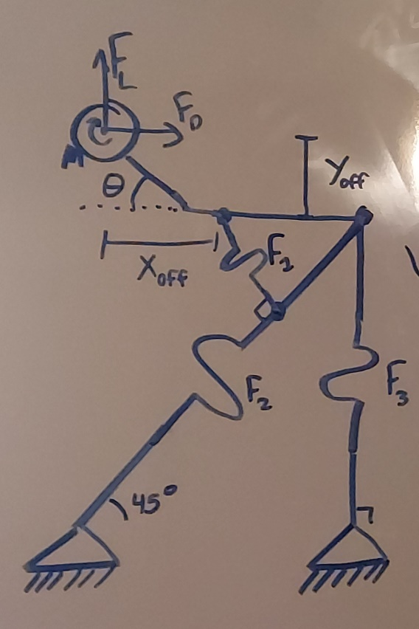

A ------------ B

**Figure 3: Statics depiction of frame design.**

A statics representation is also shown above in Figure 3. The solved equation for the forces based off of the load cell measurements is as follows:

The load cells will gather information on the forces and moments, and a pitot tube system will be used to track live airspeed. The test will only be run in appropriate conditions: low winds, no rain, little traffic. Therefore, there is a large tolerance on the performance of the pitot tube system. The pitot tube shall mount ideally on the test rig near the rear-most beam, beam 3. The pitot tube will also ideally protrude some distance out from the structure so as to not incur any turbulence effects on the pressure measurements.

The frame design uses many triangles to ensure structural integrity in the longitudinal and vertical axes. This does not protect from lateral forces an moments acting on the rig however. The primary lateral forces that may act on the rig are G loading from turns and potential resonance due to vortex shedding. Vortex shedding occurs under certain conditions regarding the Strouhal number and the geometry of the object. Assuming the conditions ARE correct for vortex shedding, the frequency of the shedding is as follows:

The goal is to ensure the test rig does not have a lateral resonance mode within the bounds of 0 to 7.8 Hz. This can be done with a simplified model and modal analysis in Solid Edge. Two diagonal braces are included on the rear column for added strength.

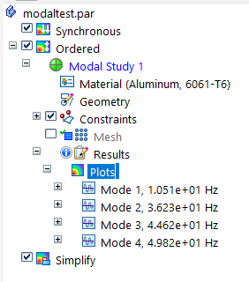

**Figure 4: Result of modal analysis on simplified model.**

The closest natural frequency is 10.51 Hz, and is also the lowest natural frequency. Since we do not expect the car’s speed to ever produce a vortex shedding of greater than 7.8 Hz, and because the difference between that and the first mode is nearly 36% different, we can safely assume that the test rig will not suffer from resonance due to vortex shedding during testing. All other forms of loading due to inertial forces can be tested with weights after assembly.

The car mounting will be done using COTS roof rails. Roof rails are a very common COTS item and a trade study is not necessary. Simple brackets and T nuts will be used to bolt the entire rig to the rails once fully assembled. The final model will look very similar to Figure 5.

**Figure 5: Final assembly model as of 2-13-2023.**

# Assembly and Testing

Blah blah blah I haven’t done finished this stage yet

# References

[1] Research Gate: “Comparison of Linear Vortex Panel Method and Finite Volume Method for Calculation of Generated Lift in Potential Flow Over Two-Dimensional Car Bodies” (<https://www.researchgate.net/figure/Streamlines-and-flow-patterns-around-the-car_fig1_347309635>)